MYTAXI SYSTEM

Use Case: <UC_USER_007– MANAGE ROUTES>

Version 1.0

Revision History

|  |  |  |  |
| --- | --- | --- | --- |
| Date | Version | Summary of Change | Author |
| 07 Jun, 2016 | 1.0 | Initial version | Phuong Do |

Distribution for Review/Approval

|  |  |  |  |  |  |
| --- | --- | --- | --- | --- | --- |
| Name | Title & Company | Issue Version | Issue Date | Review Date | Approval Date |
| Do Hoang | BA Lead - BAC | 1.0 | 07 Jun, 2016 | 09 Jun, 2016 |  |

Contents

1 Introduction 4

2 Processes 5

3 Flow of Events 5

3.1 Basic Flow: 5

Basic Flow: <Login by Third party> 5

3.1.2 Basic Flow: <Login with email> 6

3.2 Alternative Flows: 6

3.2.1 Alternative Flows: < Login by Third party failure> 6

3.2.2 Alternative Flows: < Login by Email failure> 6

4 Business Rules 7

5 Special Requirements 7

6 Supplementary Information 7

7 Related Documents 7

# Introduction

|  |  |
| --- | --- |
| ID and Name | UC_User_007-Manage Routes |
| Description | - Help users manage their routes list. |
| Actor | * Driver * Passenger |
| Relationships | Includes:   * Login   Extends:   * Detail Route * Create Route * Cancel Route |
| Pre-conditions | 1/ Successful login to the system  2/ Access to the screen Management route. |
| Post-conditions | 1/ Users can view detail routes  2/ Users can create routes  3/ User can cancel routes |

# Processes

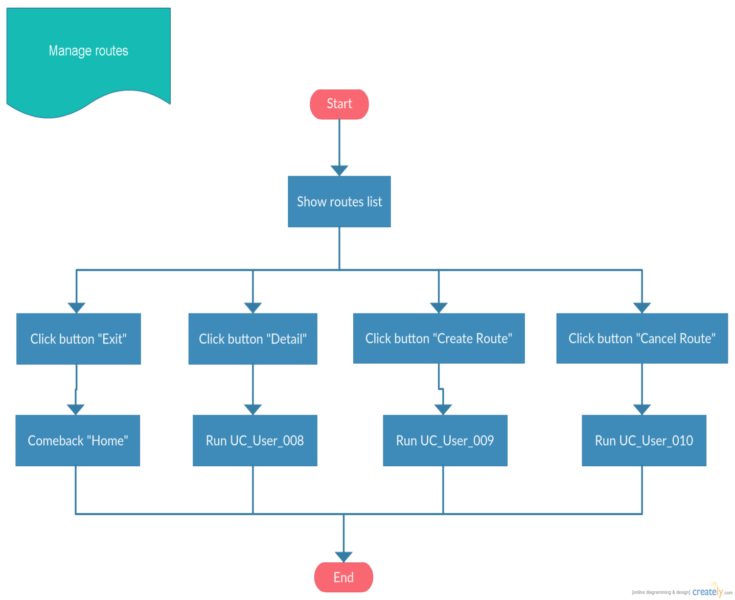

## Detail Route



## Create Route



## Cancel Route

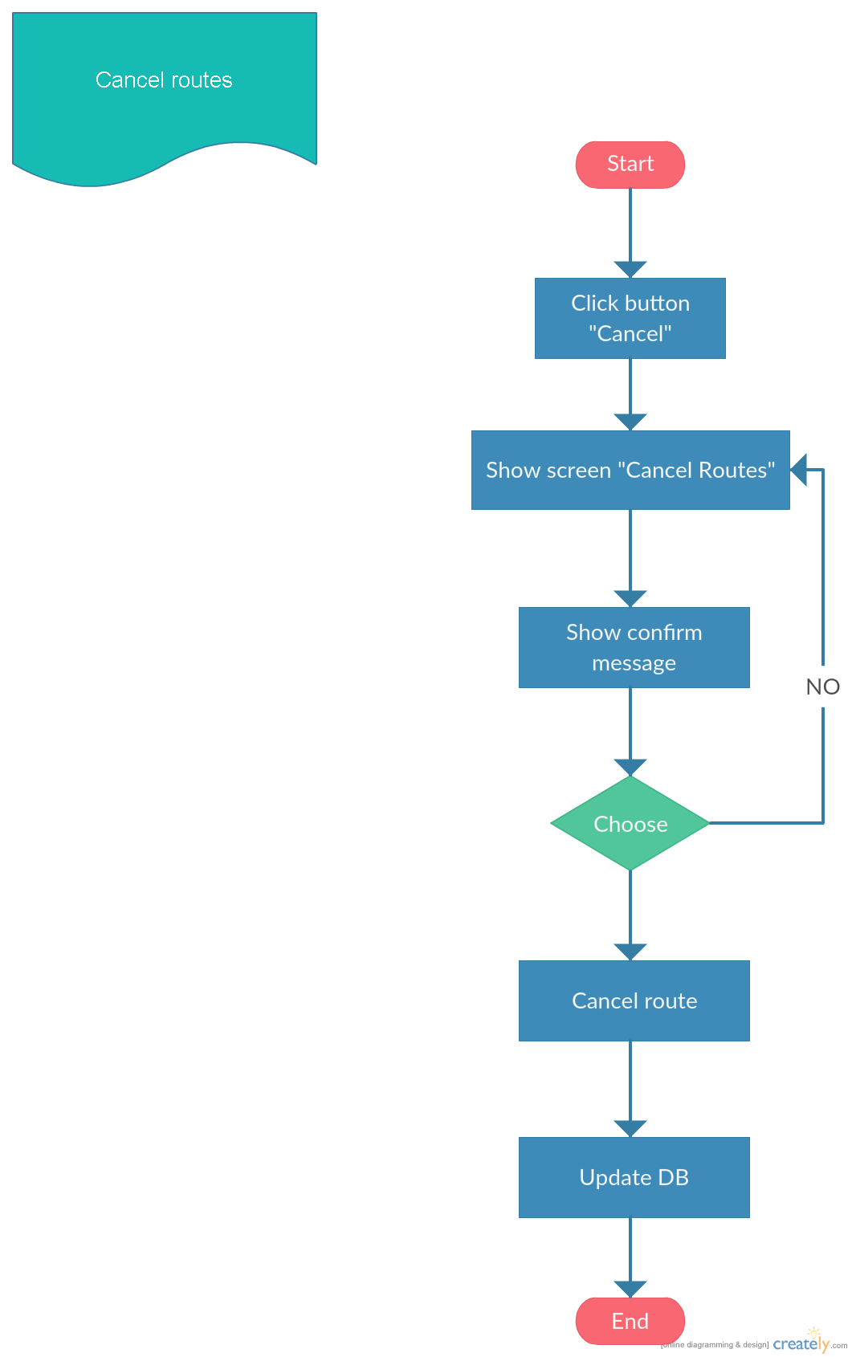

# Flow of Events

## Basic Flow:

### 3.1.1 Basic Flow: <Detail Route>

|  |  |
| --- | --- |
| **Step** | **Description** |
|  | The actor access to the screen Management route. |
|  | The actor click button “Detail Route” |
|  | The system show screen “DETAIL ROUTE” |
|  | The system show data detail on screen. |
|  | The actor click button “Next” |
|  | The screen will run next to map. |
|  | The system show map route: start and end locations of the route on the map |
|  | Click button “Exit” |
|  | Come back screen “Manage Routes” |

### 3.1.2 Basic Flow: <Create Routes>

|  |  |
| --- | --- |
| **Step** | **Description** |
|  | The actor access to the screen Management route. |
|  | The actor click button “Add new” |
|  | The system show screen “ADD ROUTE” |
|  | Actor input route information and personal information |
|  | The actor click button “Next” |
|  | The system validate data |
|  | The screen will run next to map. |
|  | Actor select start and end locations of the route on the map |
|  | Click button “Save” |
|  | The systems validate data |
|  | Save route into Database and add to the list routes |
|  | Come back screen “Manage Routes” |

### 3.1.3 Basic Flow: <Cancel Routes>

|  |  |
| --- | --- |
| **Step** | **Description** |
|  | The actor access to the screen Management route. |
|  | The actor select route in list |
|  | The actor click button “Cancel” |
|  | The system show messeage: “The system will cancel the route "ABC", do you want to continue?” |
|  | The system cancel route in Database |
|  | The system update Database |
|  | Come back screen “Manage Routes” |

## Alternative Flows:

### Alternative Flows: <Manage routes failure>

|  |  |
| --- | --- |
| **Step** | **Description** |
| 1 | Actor clicks “Manage routes” button. Actor not login into system |
| 2 | The system will displayed the “Manage routes” page with the error message “User not login into system” |
| 3 | The end |

## Exception Flows

N/A

# Business Rules

|  |  |
| --- | --- |
| **BR ID** | **Description** |
| BR1 | <Description, calculation logics, sample> |
| BR2 | <Description, calculation logics, sample> |
| BR3 | <Description, calculation logics, sample> |

# Special Requirements

<Only list out the non-functional requirements applied for this specific UC, not for the whole system. Normally it is performance requirement.>

# Supplementary Information

<Contain any additional materials that

* support to understand this use case better such as workflow, activity diagrams, data dictionary
* supplementary details for the completeness of this use case such as data specifications of entities used in the flows, message log
* golden data
* etc.

>

# Related Documents

<only needed if this document refers to many other documents, this section aims to give the readers a summary of all referenced documents>

|  |  |
| --- | --- |
| **When** | **Refer to** |
| <Purpose> | <Document ID – Name, storage location if possible> |